Market Goat Exhibitors

Information on purchasing:
Mrs. DeShazo will be purchasing goats for students who need one. Other options are available.

Equipment you will be needing soon.

Halter and Lead
In the beginning, you need to train your goat to lead. It is easiest to start with a halter and lead. Here are a couple of choices. Make sure whichever you choose will be small enough to work with your goat.
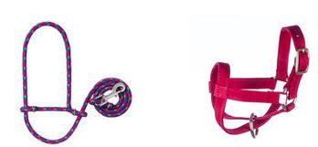

Chain collar – your choice
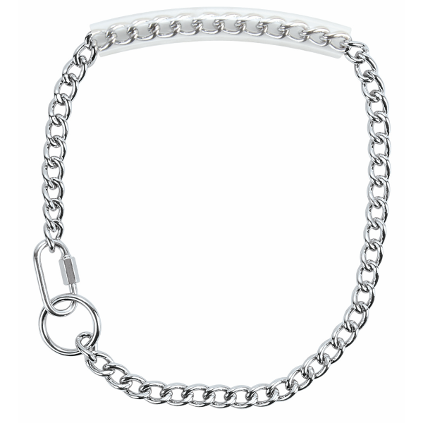 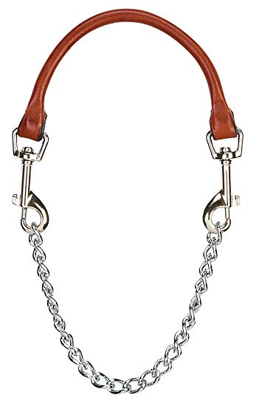 Or something similar (no spikes)

This is how it goes on the goat. You have control on the jaw of the goat.

Spandex Goat Tube (do not need this right away)
These are available lots of places. They do tear easily but they help keep the goat warm. Color doesn’t matter.
Here is what it looks like.

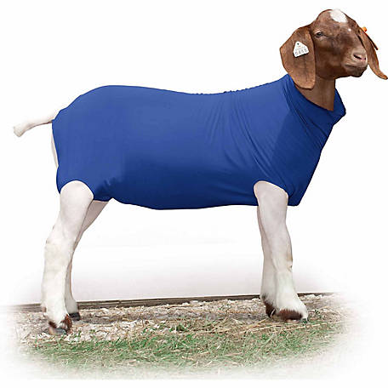

Goat Blanket (do not need this right away)
This goes on top of the Spandex Goat Tube. It helps keep the wind off and the goat warm. Here is a picture of one.
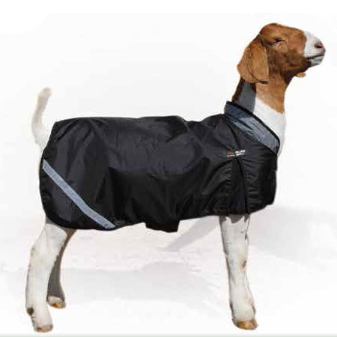
DO NOT GET A PRO-COOL BLANKET!!! It was designed to keep the goat cool! Please don’t buy this by mistake!!

Feed
This is the feed that we are currently feeding. Show Rite Advancer Plus

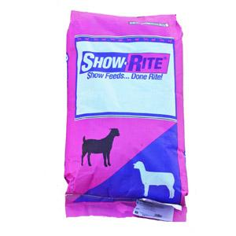
You will feed 2 times a day and as close to 12 hours apart as possible. Feed a total of 3% of your animals body weight and increase as the animal grows.

We will talk about supplements and other things we need to implement.

Bridgeport Feed does carry this feed.

Bedding
We use pelleted bedding in the barn. There are several places and brands that are available to you.

Feeding and Watering Equipment
As long as we have extras you may use our equipment. When we are out then you will need to get your own. You might even want to get your own anyway.

Blue water bucket 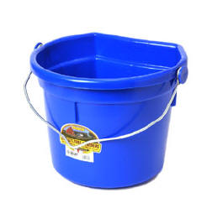

Feeder
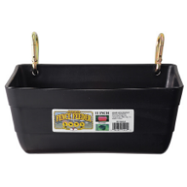

Current Exercise Program
We will be discussing what you should be doing with your animal.

The treadmill and walker are available. You will get directions on their use. This is a very important part of caring for your animal.

Stock Show Dates
Fort Worth Stock Show Jan. 22 - 25
Take goats to show and leave them – Friday, Jan. 22.
Weigh goats and hang around the show – Saturday, Jan. 23
Show days Sunday and Monday, Jan 25 and 26 – depends on your goat’s weight.
Bring goats home Monday, Jan 26

Wise County Youth Fair
The Fair is tentatively set for the week of March 1st. Will
most likely show on Thursday.
The sale is Saturday. With hard work, we should be in the hunt for a spot in the sale.

Major Entry Night
More information will be given at a later date. However, the
entries will be done early in November.

Quality Counts
To show your animal, you will need to complete the Quality Counts program. You will be receiving more information from Mrs. DeShazo.
We will need your Quality Counts Verification number for the entries.

